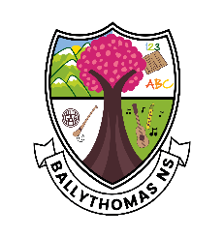
Ballythomas National School

School Closures and Important Dates 2023/2024

Term 1

August: All children back on 31st August
(Junior infants only 10 - 12 Wednesday 30th)
September: No Closures
October: Mid-term Monday 30th October to Friday 3rd November
November: See Halloween break above for closures
December: School holidays begin at 12 noon on 22nd December
Term 2
January: School re-opens Monday 8th January
February: St. Brigids Day Monday 5th February
Mid-term 15th & 16th February
March: St. Patricks Day (school closed Monday 18th March)
Easter Holidays begin on 22nd March at 12 noon
April: School re-opens Monday 8th April

Term 3
May: School closed 6th May (Bank holiday)
(school closed 6th – 10th May inclusive)
June: School closed 3rd June
Summer Holidays begin 28th June at 12 noon

Please note these days are subject to change in the event of unforeseen circumstances.

